TITLE: | AR-05 Closing Report for Month End AR
sop #: | IT-06 | revision #: | 1
EFFECTIVE DATE: | May 29, 2020
OWNER: | Tamalur Shaikh

REVIEWERS
Name | tITLE | sIGNATURE | dATE
Tamalur Shaikh | Int .NET Enterprise Web Portal Developer | Not Signed | January 01, 0001
Jerome Tacbad | Service Desk Analyst | Not Signed | January 01, 0001
Subodh Pande | WSM System Analyst | Not Signed | January 01, 0001

APPROVER
Name | tITLE | sIGNATURE | dATE
Elhadj Diallo | Business Intelligence Developer and Analyst | Not Signed | January 01, 0001

1.0 purpose
To generate reports for month end closing for Finance department to ensure everything has been posted in the system.

2.0 SCOPE
Generate Month end Reports

3.0 equipment
N/A

4.0 definitions
Definition | Explanation

5.0 Responsibility
Responsibility | Activity

6.0 policy

6.1 GENERAL
- Go to Epicor – Accounts Receivable – REPORTS – Operational – Unposted
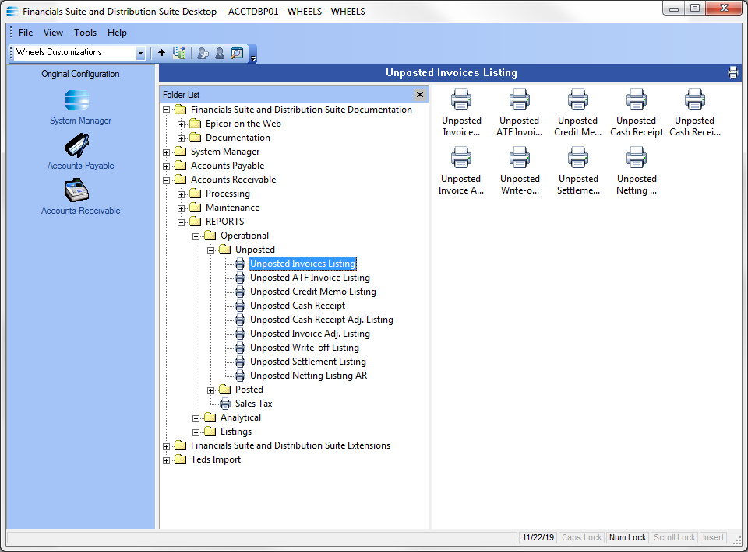

- Double click on the desired report to open click NEW
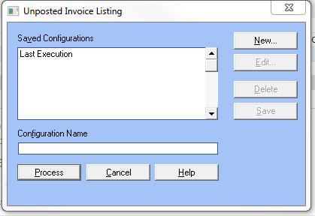
- Select Detail and click Parameters button.
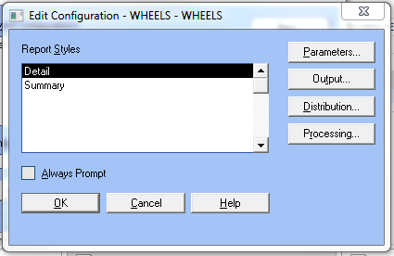
- Select Apply Date and click the Append button. Under Ranges field select Apply Date and enter the last day of the month in the Thru field as shown below.
- Then click OK.
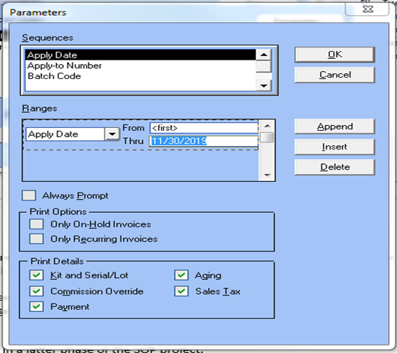
- This will bring you back to the screen below and click OK
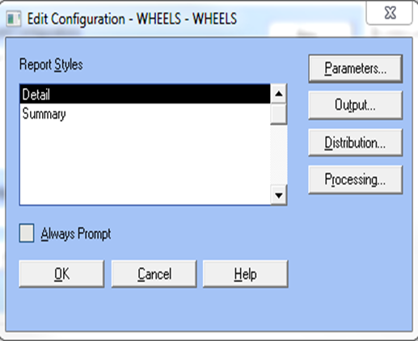
- Which will bring you back to the screen below and click Process
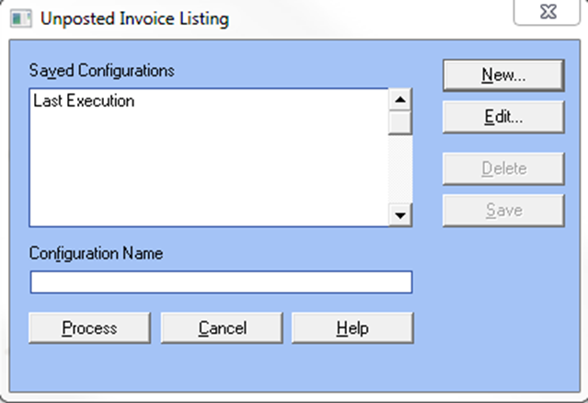
- The reports should show nothing open. If they do, they must be either posted or deleted.
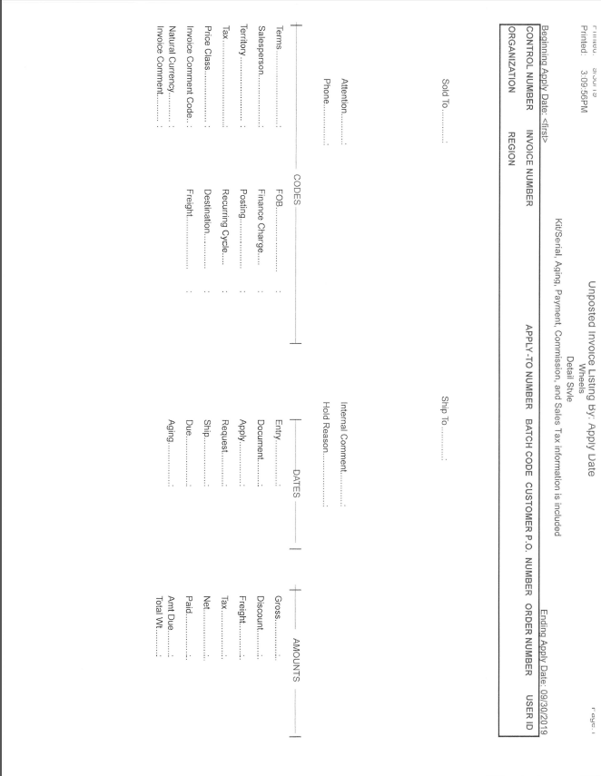

7.0 references

8.0 revision history
Revision # | Revision Date | Description
1 | May 29, 2020

